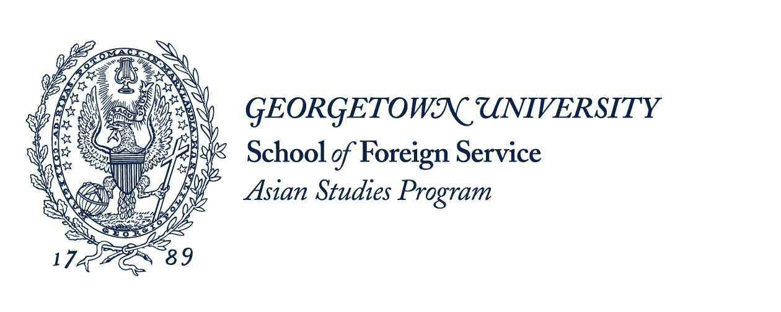
Georgetown University Asian Studies Program Postgraduate Information Session

Date: June 1st, 2015
Time: 18:00-18:30
Venue: Luce Pavilion (湖心岛鲁斯厅)

Are you interested in postgraduate study at Georgetown University? Robert Lyons, Supervisor of Academic Programs of the Asian Studies Program at Georgetown University’s School of Foreign Service, will conduct an information session for students interested in learning more about Georgetown’s MA Asian Studies degree. The presentation will also include expert advice on preparing a successful graduate school application for study in the USA. Following this overview, Robert will be available to answer questions.

