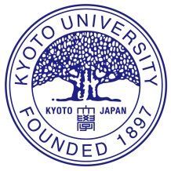
Winter Program
For the Global Future of Life, Food and Environment
Faculty of Agriculture, Kyoto University

Introduction

About Kyoto University
Kyoto University is a comprehensive research university with a student body comprising ambitious young people from diverse cultural backgrounds who are pursuing studies in a wide variety of fields. Since its foundation over 100 years ago, Kyoto University’s tradition of academic freedom has been at the core of its pioneering education and research endeavors, endowing its students and researchers with a distinct brand of talent and creativity. Based on this tradition of academic freedom and autonomy, the university encourages its students and faculty to engage in cross-disciplinary dialogues and engage in innovative and ground breaking research. From Hideki Yukawa, who, in 1949, became the first Japanese citizen to receive a Nobel Prize, to Isamu Akasaki, who was awarded the Nobel Prize in Physics in 2014, there are now nine Nobel laureates who are either alumni of Kyoto University or who were researchers at the university during vital stages of their careers. Kyoto University has produced more Nobel laureates than any other university in the Asian region.
(“Why Kyoto University?” http://www.opir.kyoto-u.ac.jp/study/en/why/)

About Faculty of Agriculture:
Kyoto University’s Faculty and Graduate School of Agriculture provide education and undertake research on a wide variety of subjects related to “Life, Food and Environment”.
At this School we aim to improve the productivity of agriculture, forestry and fisheries, as well as to preserve the environment, in which such production activities are performed. The sciences covered range from a molecular to a global level, and deal with mechanisms of life, the balance of biological interactions in the environment, material cycling on the earth, and even human activities to sustain society.
We believe that through a better understanding of life, the outcome of our studies will be the development of new and outstanding pharmaceuticals, pesticides, industrial materials, functional foods and energy resources. An overview of the nature of the education provided by this School can be gained, in part, by browsing the series of Open Courseware lectures that are accessible from the University`s website.
It is vitally important that human beings secure sufficient food in order to lead spiritually rich lives, but currently there are many negative factors that we have brought upon ourselves, such as chemical contamination, salt accumulation, and soil erosion, which limit stable crop/food production. We must establish new agrosciences to realize sustainable food production systems, and our well-being.
In order to accomplish these aims, it is also important to nourish good international relationships. We have concluded academic and student exchange agreements with many universities throughout the world, and based on these agreements we are actively participating in numerous international collaborative research projects. (Prof. Eiji Nawata, Dean, GSA)
Application Criteria
Minimum Requirements:
- Enrolled as a full time undergraduate students (2nd, 3rd or 4th grade)
- Hold an interest in concepts related to “Life, Food, and Environment”
- Hold an interest in Kyoto University’s post graduate program in agriculture related fields
- TOEFL-iBT 90 or IELTS 7.0 (attach a copy of score report)
- GPA 3.2/4.0 (80%)
- Join travel insurance in prior to departure to Kyoto

Outline
Date and place: from January 14 to January 25, 2018 at Faculty of Agriculture, Kyoto, Japan
Capacity: 5 students from one university (totally 15 undergrad students from three universities)
Selection: by application documents screening and by each university’s criteria
Requirements: please refer to section below
Scholarship: 100,000 JPY (about 6,600 CNY) / person (may change depending on conditions)

Schedule (subject to minor adjustments)

Day1(Jan14) | Arrival to Kyoto
Day 2 | 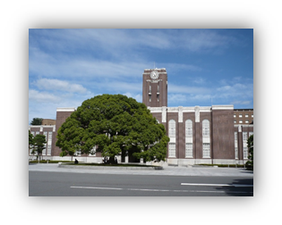  Opening session, Orientation,  Campus tour
Day 3-5 | Special lectures: on Life, Food and Environment for 9 billion population  Experiments: making High Quality Tofu with Kyoto University students
Day 6-9 | 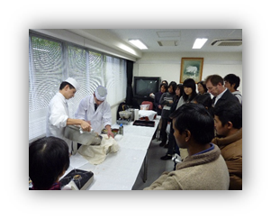  Special lectures: on Japanese advanced technologies related to food, energy, and environment by company professionals/  Japanese food culture and tradition
Day 10 | Field trip to one of leading manufacture, i.e. YANMAR
Day 11 | Final presentation and closing session
Day12(Jan25) | Departure from Kyoto

Application Submission to: ______Fill contact person information of each university out_________

Deadline: July 31, 2017

