Best Viewed in Browser
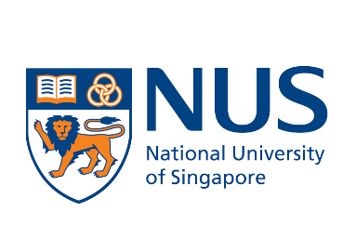
NATIONAL UNIVERSITY OF SINGAPORE (NUS)
YOUNG FELLOWSHIP PROGRAMME
24-28 June 2024

Delve into the Practical Use of
Generative Artificial Intelligence (AI)

The National University of Singapore (NUS) invites bright young students
from around the world to get a glimpse of our world-class graduate education
in this fellowship programme!

One Week at NUS in Singapore,
Plus an Online Project Presentation Four Weeks Later

Students selected for the fellowship will come to Singapore for a one-week experiential learning line-up at NUS, where they will be immersed in thought-provoking seminars, engaging workshops and behind-the-scenes tours. They will then return to their home countries and work online together with fellow participants on a project, to be presented online four weeks after the on-site programme.

Funded by NUS
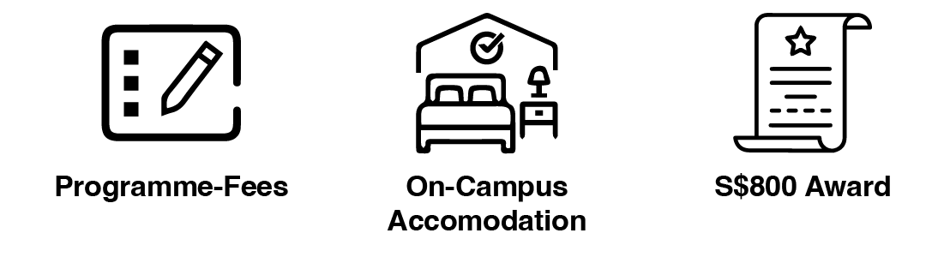
Subject to Terms and Conditions.

Find Out More Now
National University of Singapore
University Town, Education Resource Centre, 8 College Avenue West Singapore 138608

© 2024 NUS. All rights reserved.

